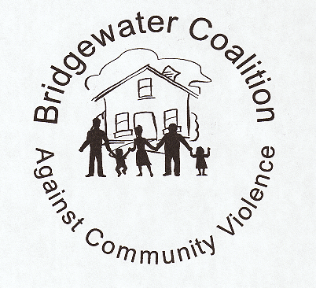

Cost
Instructors:
Cpt. Carl H. Macdermott, III (Retired) &
Lt. Scott R. Hile
Email:
Rebekah Caylor at
Email rebekah@bpd5k.com

Online
www.bridgewaterpolice.org

Eventbrite:
https://www.facebook.com/profile.php?id=61560529265602&mibextid=ZbWKwL

Cost
$25 Donation
Proceeds go to the Bridgewater Police Foundation
An interactive 2-week program offered to women ages 15 and older. Learn the best techniques to protect yourself through demonstrations and interactions between students and instructor.

Monday

September 23 and September 30, 2024
6 p.m. to 8:30 p.m.
Classes will be held at the Bridgewater Sports Complex,
350 Bedford Street, Bridgewater, MA 02324

Bridgewater Police Department
Sponsored by: Bridgewater Police Chief Christopher Delmonte
Self DEFENSE
Introduction to Women’s Self Defense

To Register

